Koala Woman asking the World to Cuddle for Koalas

Deborah Tabart OAM, the CEO of the Australian Koala Foundation (AKF) yesterday set Communication Professionals from all around the world a $5 million challenge.

Ms Tabart floated the idea during her presentation as the 2011 recipient of the prestigious International Association of Business Communicators (IABC) EXCEL Award at the IABC World Conference in San Diego.

The Award is a grand moment in her career that she is delighted about and now wants to set future goals for herself and her organization. The AKF’s Cuddles for Koalas unites her commitment to communication and her passion for saving the koala.

“I am encouraging the IABC members to host events for their companies to collectively raise $5 million for the Australian Koala Foundation to secure our future.

“In my presentation, I explained that our communication strategy is always about celebrating the beauty and grandeur of this beautiful creature”, said Ms Tabart.

Cuddles for Koalas which highlights this strategy is a very fitting promotion to have in the year the Australian Koala Foundation celebrates their quarter century milestone.

“Now the AKF is 25 years old, we must look to the future; the AKF has a bold, pioneering organization, funded every single dollar towards mapping, research and the public education of a rapidly declining species.

“It is now time to secure the AKF’s future with a collective five million dollar contribution so that our organization can continue to be instrumental in ensuring the koala survives for the next 25 years and beyond.

“The coming era is crucial for the koala and the fragile planet. Through mapping, research and education, the AKF is in a strong position to facilitate the recovery of the wild population,” said Ms Tabart

She feels this is a great opportunity for people all over the world to come together and celebrate the koala’s future.

“It is a very happy and fun initiative that focuses on the joy the koala gives us rather than the doom and gloom and seriousness of the koala’s plight”, said Ms Tabart.

Cuddles for Koalas is due to be officially launched to the public on 1st July giving everyone time to organize an event for Save the Koala Month in September, the AKF’s peak time to raise funds and awareness of the plight of the koala.

The AKF is also hoping to have further reason to celebrate this Save the Koala Month with the Senate Inquiry into The status, health and sustainability of the koala population releasing their report on the 24th August.

“I am hoping that it will recommend among other things; the immediate protection the 50 species of koala trees, listing the koala as ‘vulnerable’ under Australian legislation and the implementation of a National Koala Act”, said Ms Tabart.

- ENDS -

For interviews contact Deborah Tabart OAM, CEO Australian Koala Foundation on her cell phone 1 (310) 383 3957
Further Information
Media Calls/Interview opportunities:
Deborah Tabart OAM, CEO Australian Koala Foundation, will be available for interviews, Deborah can be contacted on 1 (310) 383 3957
Related Media Releases:
Koala Woman Coming to San Diego
The Koala Calls on U.S. Friends
Media releases can be downloaded from savethekoala.com/media.html
High resolution images of koalas and Deborah Tabart OAM for print can be downloaded from www.savethekoala.com/pressimages.html
All images downloaded from this webpage must be referenced,
Photo courtesy of the Australian Koala Foundation www.savethekoala.com
Links to Background Information:
About Deborah Tabart available at savethekoala.com/deborahtabart.html
About the Australian Koala Foundation available at savethekoala.com/akfprofile.html
Does your Publication need Filler Advertisements?
As a not-for-profit organization to spread our message, the Australian Koala Foundation relies on publications generously running their ads free of charge when they have the space due to a last minute cancellation.
Ads can be sized to any specifications with a very quick turnaround. If you would like the ads below sized to your publications specifications to keep on file please email Connor Reidy on connor@savethekoala.com or Jill Richardson on jill@savethekoala.com.
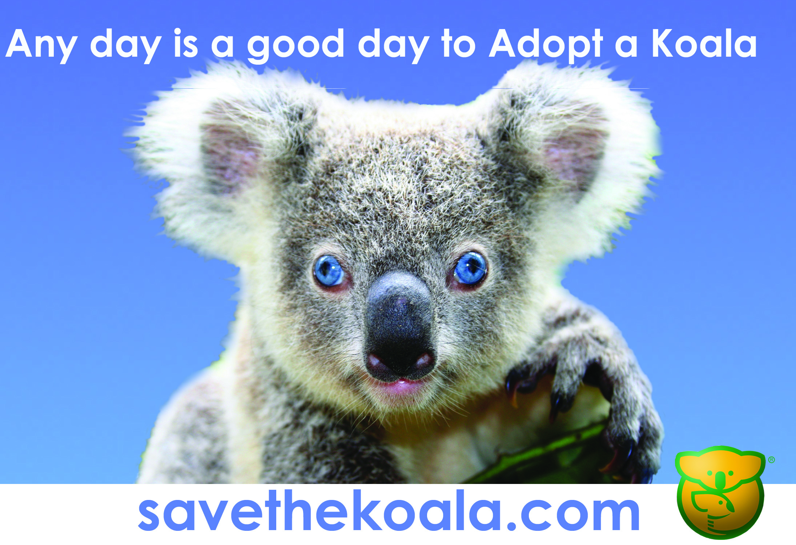
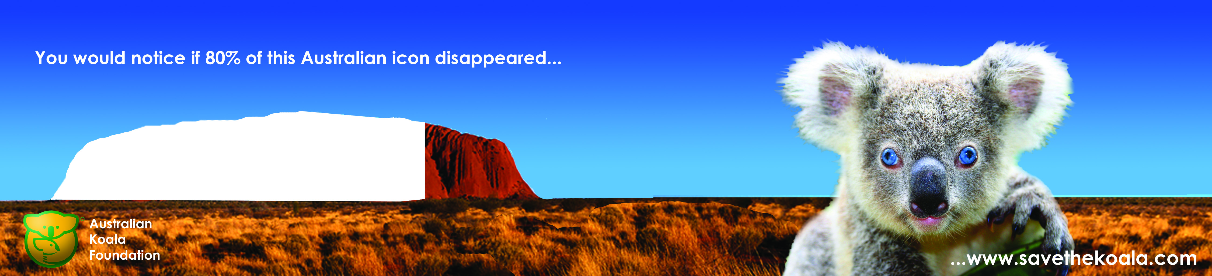
To find out ways to help the Australian Koala Foundation save our koalas, visit the website at www.savethekoala.com.

